**Navigation:** React Router offers various ways to navigate between these routes, providing a smooth user experience without full page reloads. Some common methods include:

* **Links:** By using the Link component from React Router, you can create clickable elements that trigger navigation to the specified route. When clicked, the URL is updated in the browser's address bar, and the corresponding component is rendered.

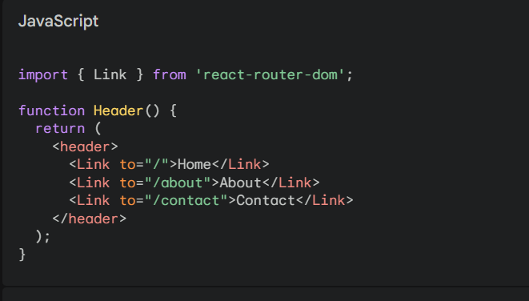

**Programmatic Navigation:** You can leverage the useNavigate hook (or the navigate function in older versions) to programmatically navigate to different routes from within your components. This is useful for actions like form submissions or button clicks that trigger route changes.

